Download the nexus from link below

<https://www.sonatype.com/download-oss-sonatype>

Latest link

https://help.sonatype.com/repomanager3/download

Unzip the file and place it on any path in windows

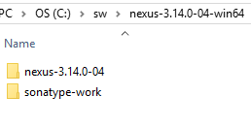

Now open command prompt in Administrator mode and go to that folder **nexus-3.13.0-04/bin**

Run command >>.\nexus /install

It will create nexus service

Open service and search for nexus

And start that service, it will run on port 8081

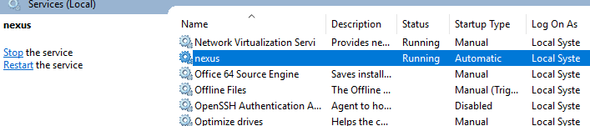

Now open <http://locahost:8081>

Sign in with user name admin and default password admin123

In latest version you can get it under sonatype-work\nexus3\admin.password

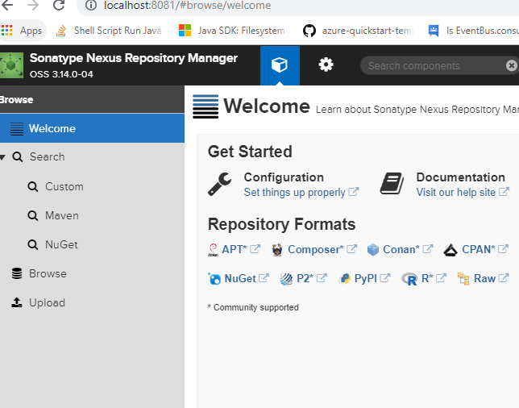

To Create private Repository go to setting  tab

Click on Repository

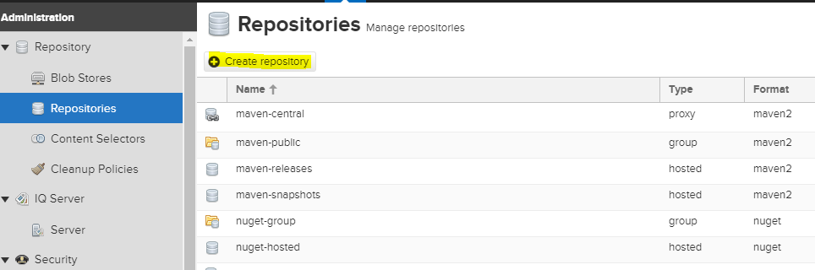

Click Create Repository

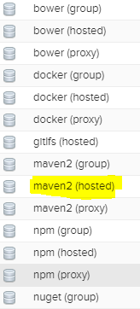

Click maven2(hosted)

First create snapshot repository to hold all snapshot version

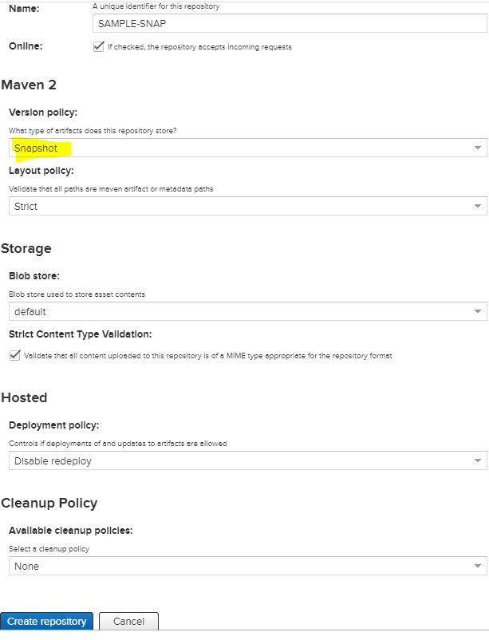

Provide some name and select Snapshot as version policy and create repository

Same way creates one release repository in this case choose version policy as Release

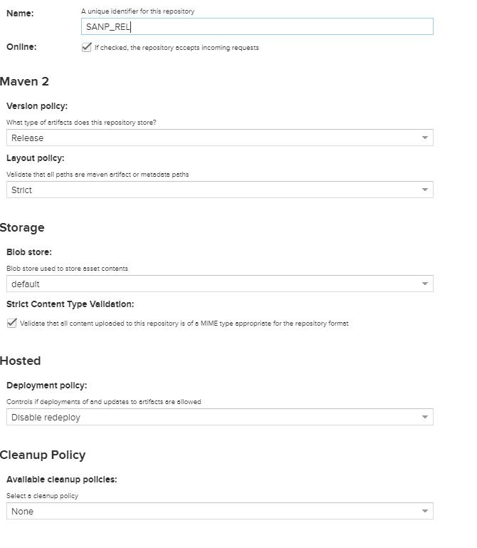

Now to upload some artifact on the repo click on  icon at top

Click on Browse

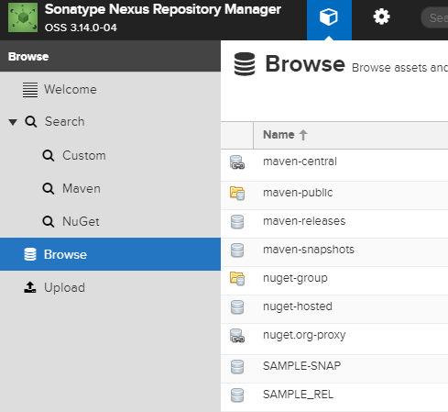

Select SAMPLE_REL

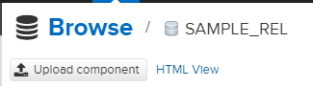

Click on Upload component at the top

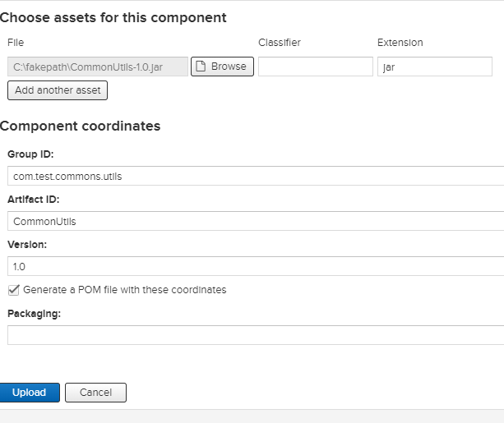

Choose jar path and specify proper Group Id, Artifact ID and Version and click Upload

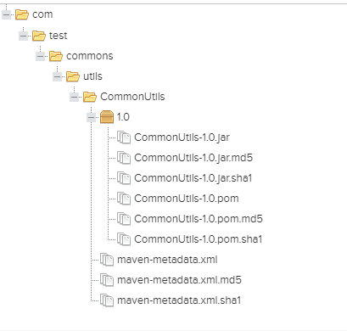

Now we can use that artifact as dependency in our build

To copy the repo url go to repository and click on copy button

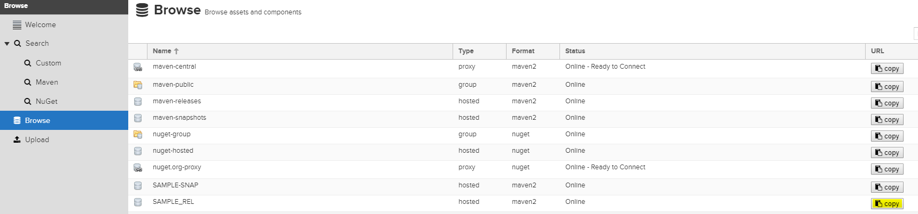

Now we can define this url to build.gradle under repository

repositories {  
   
 maven {url **"http://clojars.org/repo/"** }  
 maven {url **"http://localhost:8081/repository/SAMPLE_REL/"**}  
 mavenCentral()

}

Also we can add the dependency for that artifact

compile **"com.test.commons.utils:CommonUtils:1.0"**

to include in sbt project

build.sbt

|  |
| --- |
| name := "Loader"  version := "0.1"  scalaVersion := "2.11.8"  // to include repository  resolvers += "RSI" at "http://localhost:8081/repository/SAMPLE_REL/"  libraryDependencies ++= Seq(  "org.apache.spark" %% "spark-core" % "2.1.0" % "provided",  "org.apache.spark" %% "spark-sql" % "2.1.0" % "provided",  "org.apache.spark" %% "spark-hive" % "2.1.0" %"test",  "org.json4s" %% "json4s-jackson" % "3.2.11" % "provided",  "com.typesafe" % "config" % "1.3.1",  "org.apache.kafka" % "kafka-clients" % "2.0.0",  "com.rsi.commons.utils" % "CommonUtils" % "1.0",  "com.rsi.audit" % "AuditMessage" % "1.0"  )  // to include sbt project  //lazy val auditMessage = RootProject(file("../AuditMessage"))  //val main = Project(id = "loader", base = file(".")).dependsOn(auditMessage)  test in assembly := {}  assemblyOption in assembly := (assemblyOption in assembly).value.copy(includeScala = false)  assemblyMergeStrategy in assembly := {  case PathList("META-INF", xs @ _*) => MergeStrategy.discard  case x => MergeStrategy.first  } |